**COLLEGE NAME**

**College Name**

|  |  |
| --- | --- |
| **NAME OF STUDENT:** | **CLASS:** |
| **SEMESTER/YEAR:** Sem 6 | **ROLL NO:** |
| **DATE OF PERFORMANCE:** | **DATE OF SUBMISSION:** |
| **EXAMINED BY:** | **EXPERIMENT NO:** |

**Title:** Case Study on Global Innovation Network and Analysis (GINA)

**Aim:** Write a case study on Global Innovation Network and Analysis (GINA). Components of analytic plan are 1. Discovery business problem framed, 2. Data, 3. Model planning analytic technique and 4. Results and Key findings.

1. **Introduction**

In today's fast-paced global economy, companies across industries are continually striving to innovate to stay ahead of the curve. EMC Corporation, a leading technology firm during the period of this case study, recognized the critical importance of innovation in maintaining competitiveness and driving growth. However, like many multinational corporations, EMC faced the challenge of effectively harnessing the diverse talents and ideas dispersed across its global network. EMC Corporation (EMC) develops, delivers and supports the information technology (IT) industry's range of information infrastructure and virtual infrastructure technologies and solutions.

The emergence of the digital age brought about a shift in the dynamics of innovation. No longer confined to traditional R&D centres, innovation now thrived in a decentralized manner, with pockets of creativity and expertise scattered around the world. This posed a unique challenge for EMC: how to identify, nurture, and leverage these dispersed sources of innovation to fuel company-wide growth and success.

In response to this challenge, EMC embarked on a strategic initiative: the establishment of the Global Innovation Network and Analysis (GINA) program. GINA was conceived as a dedicated team tasked with systematically analysing EMC's global innovation landscape, with the aim of unlocking the full potential of the company's global network.

The primary objective of GINA was clear: to bridge the gap between EMC's diverse global operations and its overarching innovation goals. This involved not only identifying and connecting with hidden innovators across various locations but also tracking promising research areas, measuring the impact of innovation efforts, and fostering collaboration between internal teams.

At its core, GINA represented EMC's commitment to a data-driven approach to innovation. By leveraging advanced analytics techniques and tapping into a diverse array of data sources, GINA aimed to gain actionable insights into the company's innovation ecosystem. These insights would then inform strategic decisions, driving continuous improvement and fostering a culture of innovation across the organization.

In the following sections of this case study, we will delve deeper into the establishment and implementation of the GINA program, exploring the methodology employed, the key findings achieved, and the broader implications for EMC's innovation strategy. Through this exploration, we aim to uncover the transformative power of data-driven approaches in unlocking the full potential of innovation within organizations.



*Figure 1: EMC – Global Managed Networks Services Market Overview*

1. **Background**

In the dynamic landscape of technology, EMC Corporation stood as a stalwart, renowned for its innovative solutions and global reach. However, even amidst its successes, EMC recognized the pressing need to adapt to evolving market dynamics and harness its global resources more effectively. The genesis of the Global Innovation Network and Analysis (GINA) program stemmed from this recognition, as EMC sought to optimize its innovation capabilities and capitalize on the wealth of talent within its global network.

Traditionally, innovation within corporations often cantered around centralized R&D facilities or corporate headquarters. However, with the advent of globalization and digital connectivity, the innovation landscape underwent a paradigm shift. Innovation hubs emerged across the globe, fuelled by local expertise, market insights, and cultural nuances. This decentralized model posed both challenges and opportunities for companies like EMC.

Identifying Hidden Innovators: EMC recognized that innovation often lurked in unexpected places within the organization. GINA sought to uncover these hidden innovators, individuals with unique insights and expertise, who could drive transformative change.

Tracking Promising Research Areas: In the fast-paced world of technology, identifying emerging trends and promising research areas was crucial. GINA aimed to monitor developments in various fields and forge strategic partnerships with leading academic institutions and research organizations.

Measuring Innovation Impact: Innovation without impact is meaningless. GINA endeavoured to develop metrics and methodologies to assess the effectiveness of innovation efforts, ensuring that resources were allocated judiciously and yielding tangible outcomes.

Fostering Collaboration: Collaboration lay at the heart of GINA's mission. By facilitating knowledge sharing, fostering cross-functional collaboration, and breaking down barriers to communication, GINA aimed to create a culture of innovation that permeated every corner of the organization.

In essence, GINA represented EMC's proactive response to the evolving dynamics of innovation in the digital age. By embracing a data-driven approach and leveraging its global resources more effectively, EMC sought to maintain its position as a leader in the technology sector and drive sustained growth in an increasingly competitive landscape.

|  |  |  |
| --- | --- | --- |
| **Sr No** | **Objective** | **Strategy** |
| 1. | Identifying Hidden Innovators | Conducting talent hunts, promoting idea-sharing platforms |
| 2. | Tracking Promising Research Areas | Monitoring industry trends, forging academic partnerships |
| 3. | Measuring Innovation Impact | Developing metrics for innovation efforts |
| 4. | Fostering Collaboration | Facilitating knowledge sharing, promoting cross-functional projects |

*Table 1: EMC – Objectives Vs Strategies Used*

1. **Methodology:**

The methodology employed by the Global Innovation Network and Analysis (GINA) program was characterized by a systematic and data-driven approach. GINA's methodology can be broken down into four key components, aligning with the components of the analytic plan:

*Figure 2: GINA Methodology key components*

1. **Discovery - Business Problem Framed:**

GINA's methodology began with a thorough understanding of the business problem at hand: EMC's need to optimize its global innovation network. This involved:

* Conducting stakeholder interviews and workshops to identify key pain points and challenges faced by various departments and business units within EMC.
* Framing the business problem in a clear and concise manner, focusing on the need to identify hidden innovators, track promising research areas, measure innovation impact, and foster collaboration.
* Aligning the objectives of the GINA program with the broader strategic goals of EMC, ensuring that the initiative addressed critical business priorities.

*Figure 3: GINA Data Analytics Life Cycle Phases*

1. **Data**

Data served as the foundation of GINA's analytical approach, providing the raw material from which insights could be derived. GINA's data collection efforts encompassed:

* Internal Data: GINA tapped into EMC's vast repository of internal data, including employee profiles, project details, collaboration records, patents, and communication channels. This data provided insights into the company's internal innovation landscape.
* External Data: GINA supplemented internal data with external sources, such as industry trends, competitor analysis, university publications, and market research reports. This broader perspective helped contextualize EMC's innovation efforts within the larger industry landscape.
* Qualitative Data: GINA conducted interviews, surveys, and participated in industry events to gather qualitative insights from key stakeholders. These qualitative data sources provided nuanced insights into the cultural and organizational factors influencing innovation within EMC.

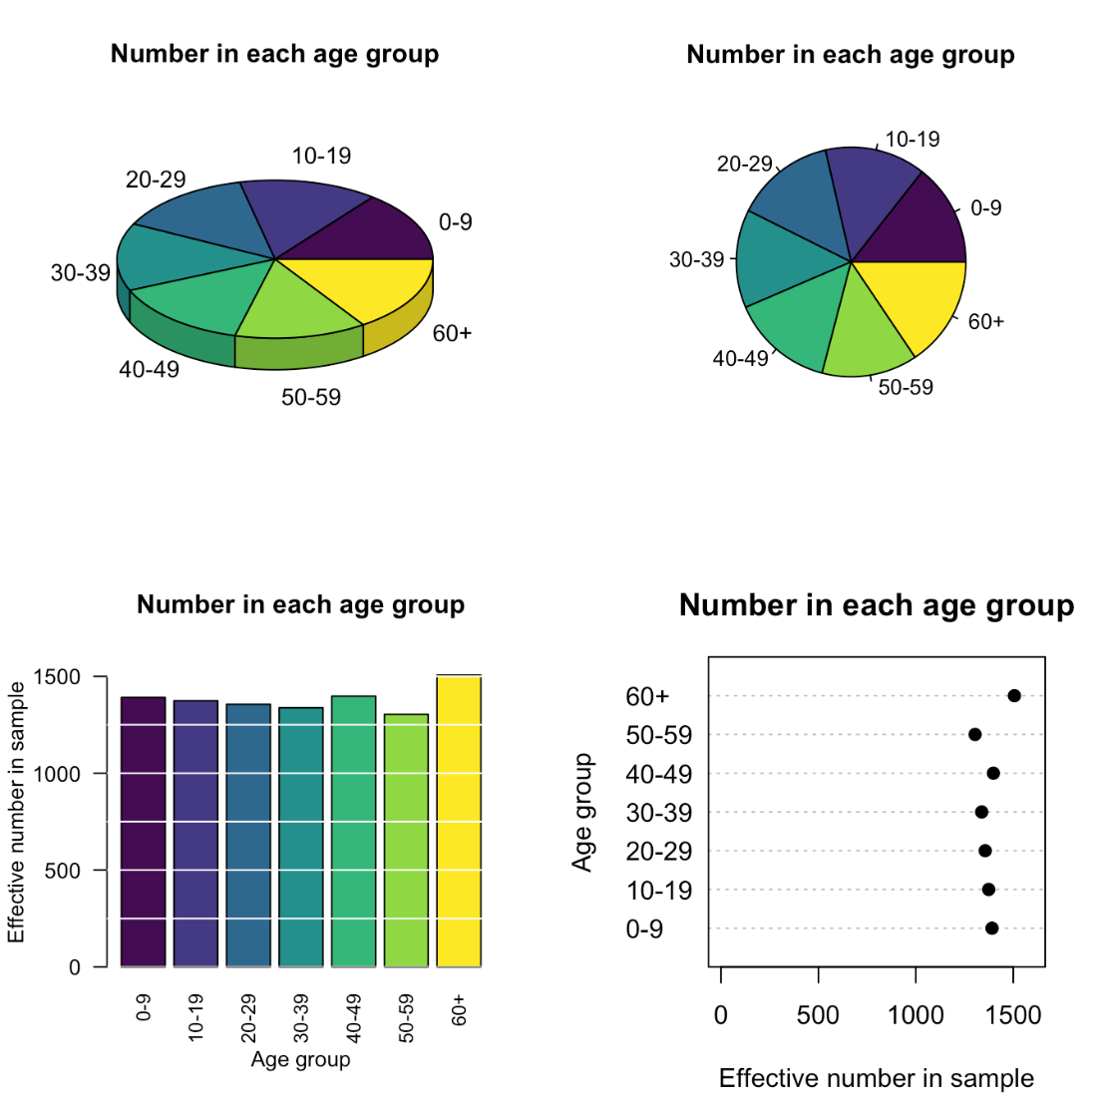

*Figure 4: Different graphs for the same data set*

1. **Model Planning - Analytic Technique:**

With a robust understanding of the business problem and access to diverse data sources, GINA proceeded to plan its analytical approach. This involved:

* Descriptive Analytics: GINA employed a variety of descriptive analytics techniques, including network analysis, social network analysis, and text mining. These techniques helped identify patterns, trends, and key players within EMC's innovation ecosystem.
* Predictive Analytics: GINA leveraged predictive analytics techniques, such as machine learning algorithms, regression analysis, and sentiment analysis, to forecast future trends and potential collaborations. By analysing historical data and extrapolating insights, GINA aimed to anticipate future innovation opportunities and challenges.

|  |  |  |
| --- | --- | --- |
| **Point** | **Descriptive Analytics** | **Predictive Analytics** |
| Purpose | Summarizes data | Forecasts future outcomes |
| Input Data type | Basic statistics (e.g., measures of central tendency, variability, frequency) | Utilizes historical data and statistical models |
| Output | Provides insights into past events | Predicts future trends or events |
| Presentation | Simple presentation of data (e.g., Covid-19 statistics graphs) | Identifies patterns and makes predictions based on existing data |

*Table 2: Difference between Descriptive Analysis and Predictive Analysis*

1. **Results and Key Findings:**

The culmination of GINA's methodology was the generation of actionable insights and key findings. Through its analytical efforts, GINA achieved several noteworthy outcomes:

* Identification of "Boundary Spanners" and Hidden Innovators: GINA identified individuals within EMC who served as "boundary spanners," bridging gaps between departments and possessing unique expertise. These hidden innovators were instrumental in driving innovation within the organization.
* Tracking Innovation Trends: GINA's longitudinal studies provided valuable insights into the effectiveness of different innovation initiatives over time. By tracking innovation trends, GINA enabled EMC to adapt its strategies and allocate resources more effectively.
* Promotion of Knowledge Sharing: GINA's efforts facilitated knowledge sharing and collaboration among internal teams, breaking down silos and fostering a culture of innovation within EMC.
* Cultivation of New Intellectual Property: By identifying promising research areas and forging partnerships with universities, GINA contributed to the cultivation of new intellectual property and innovation within EMC.

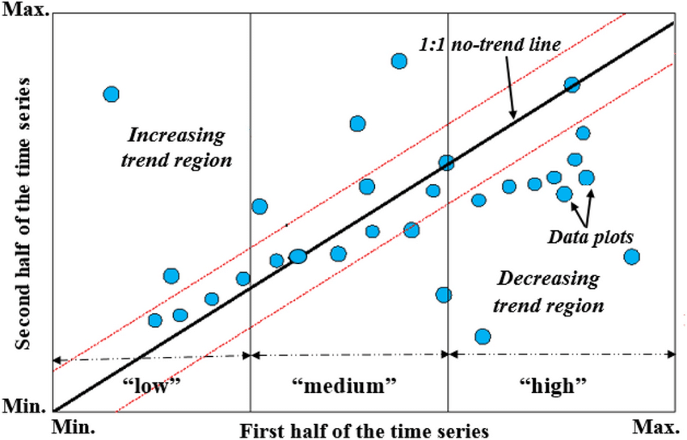

*Figure 5: GINA’s Longitudinal Studies, an example of the innovative trend analysis (ITA) using line graph.*

1. **Conclusion**

The Global Innovation Network and Analysis (GINA) program represented a significant milestone in EMC Corporation's journey towards unlocking the full potential of its global innovation network. Through a systematic and data-driven approach, GINA enabled EMC to overcome the challenges of harnessing innovation across diverse geographic locations and business units. The program's emphasis on identifying hidden innovators, tracking innovation trends, promoting knowledge sharing, and cultivating new intellectual property yielded tangible results and sparked transformative discussions within the organization.

The success of GINA underscored the transformative power of data analytics in driving innovation and organizational growth. By leveraging diverse data sources and employing advanced analytical techniques, GINA achieved significant outcomes within budget constraints. The program's ability to bridge the gap between EMC's global resources and its overarching innovation goals demonstrated the value of a strategic approach to innovation management.

Moving forward, the key findings and insights generated by GINA would continue to inform EMC's innovation strategy and shape its approach to driving innovation. The program's emphasis on continuous improvement and its commitment to fostering a culture of innovation positioned EMC for sustained success in the rapidly evolving technology landscape.